**Traffic Violation Analysis Report**

Data Description

Data contents 35 columns and 1,000,000 observations, however, only 10,000 observations have been read 25 columns.

9980 with no null value has been saved into new CSV file and saved for faster data process and manipulation.

The 25 columns are: Belts, Personal, Injury, Property Damage, Fatal, Commercial License HAZMAT, Commercial Vehicle, Alcohol, Work Zone, State, Vehicle Type Year, Make, Model, Color, Violation Type, Charge, Article, Contributed to Accident, Race, Gender, Driver State, Drive City, DL State, Arrest Type.

Using Pie ,Bar for analysis

Question what is the race that has committed violation and what type of violation is it?

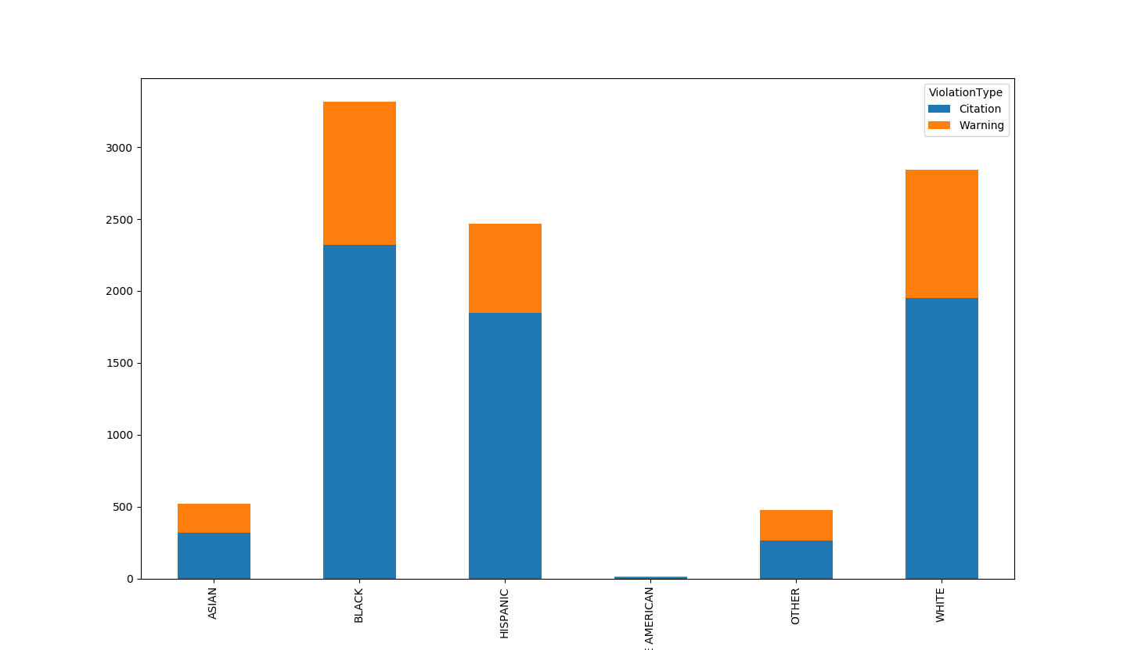



Question which month with most violation ?

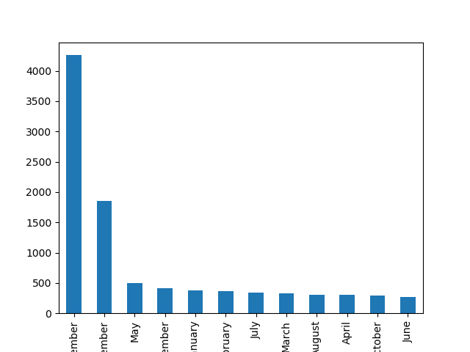

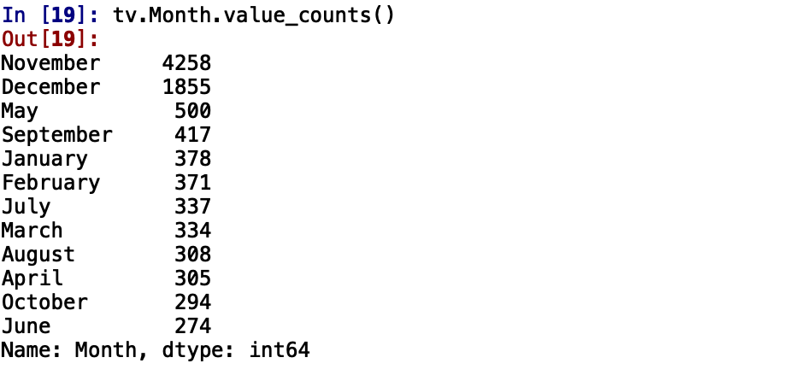

**Conclusion**

Data Need more investigation and more future survey

Most committed Traffic violation was made by males but in percentage terms both male and female committed roughly the same level of violations

Most Traffic violation committed by Black Race

From the data, we can establish that the police were not overly harsh as a 3rd of all stoppages let to only a warning being issued rather than a citation.

We see most violations on Thursday and Friday which might be an indication of work week fatigue kicking in.

Moreover, November and December have most violation presumably because of the holiday session and extra vigilance around this time by the police to discourage drunk driving.